NAME-SALONI MAGGO

COURSE-BCA 6 B

Roll no-39

UNIVERSITY ROLL NO- 1121120

SET B

PROGRAM OUTPUT

P3-Bresenham circle drawing algo Output

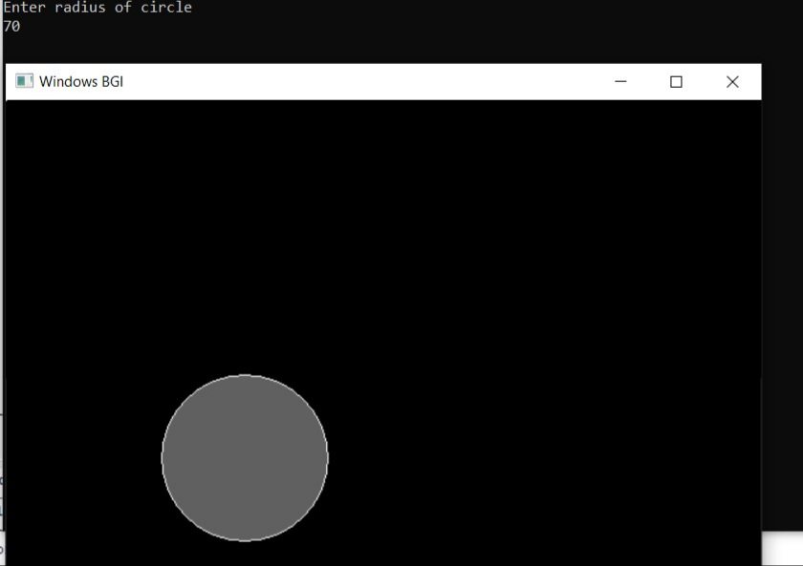

P2- WRITE A PROGRAM TO IMPLEMENT 2-D TRANSFORMATION OF A GIVEN TRIANGLE.

OUTPUT

